MOVERS TRANSPORT SYSTEM

NAME: JAMES MUKUVI NGANDU

SCHOOL: KITUI SCHOOL

INDEX NO: 13300007012

YEAR: 2021

# **DECLARATION**

I James Mukuvi Ngandu do hereby declare this project to be my on. The project submitted to the Kenya National Examination Council is work of my mind and not copied elsewhere.

# **DEDICATION**

I dedicate this project to my beloved aunt Mrs. Chambi For supporting me in my studies and mentoring me.

# **ACKNOWLEDGEMENT**

First and foremost, I thank the Almighty God for awarding me with adequate knowledge to start the project.

Secondly, I would thank my computer teachers Mr. Mwendwa and Mr. Kitonga for preparing me in advance with adequate skills.

Lastly, I thank my brother for encouraging me towards starting the project.

Table of Contents

**1** **DECLARATION** 2

**2** **DEDICATION** 3

**3** **ACKNOWLEDGEMENT** 4

**4** **SYSTEM ANALYSIS** 7

**4.1** **PROBLEM DEFINITION** 7

**4.2** **GENERAL OVERVIEW OF THE EXISTING SYSTEM** 8

**4.3** **Overview of the proposed system** 8

**4.4** **Objectives of the new system** 8

**4.5** **Benefits of the proposed system** 8

**4.6** **Scope** 8

**5** **FEASIBILITY REPORT** 9

**5.1** **Economic feasibility** 9

**5.2** **Schedule feasibility** 9

**5.3** **Technical feasibility** 9

**5.4** **Operational feasibility** 9

**6** **Information gathering** 9

**7** **SYSTEM DESIGN** 10

**7.1** **SYSTEM FLOW CHART** 10

**8.1** **Tables** 13

***8.1.1*** ***Membership table*** 13

***8.1.2*** ***Drivers Table*** 13

***8.1.3*** ***Loaders Table*** 13

***8.1.4*** ***Groups Table*** 13

***8.1.5*** ***Goods Table*** 13

***8.1.6*** ***Vehicles Table*** 13

***8.1.7*** ***Orders Table*** 14

***8.1.8*** ***Expenses Table*** 14

***8.1.9*** ***Offences Table*** 14

**8.2** **Input design** 15

***8.2.1*** ***Membership form*** 15

***8.2.2*** ***Vehicle form*** 15

***8.2.3*** ***Orders form*** 15

**8.3** **Output design** 16

**8.3.1** **Membership report** 16

**8.3.2** **Vehicle report** 16

**8.3.3** **Drivers report** 16

**8.3.4** **Orders report** 16

# **SYSTEM ANALYSIS**

## **PROBLEM DEFINITION**

Movers is a company that provides transportation for various agricultural goods for farmers between farms and retail outlets. It transports produce such as cereals, livestock and perishable goods like milk, eggs, fish and flowers. The company also transports farm inputs such as fertilizer, manure, herbicides, pesticides and seeds for planting to the farms. Members register manually as large scale farmers or small scale farmers and this has led to the loss of several documents. There is improper customer servicing and poor record storage. These problems has led the company to propose for a computerized system to cater for their needs.

## **GENERAL OVERVIEW OF THE EXISTING SYSTEM**

The existing system had the following drawbacks:

1. Delayed delivery of goods o customers due to poor time schedule.
2. Labor intensive due to high payment too many workers.
3. Improper storage of records as some of records used to get lost hence could not be traced due to lack of back up.

## **Overview of the proposed system**

The proposed system will be able to do the following:

1. Improve customer’s service.
2. The system will provide reports for entry of data.
3. The system will lead to increased profit.
4. User friendly and data security is enabled.

## **Objectives of the new system**

1. There will be high profit as the number of workers will be reduced by the computerized system.

2. The records will be kept safe and up to date as the computerized system will update the records and also provide back up.

3. It will improve the service offered to the customers as the time schedule will be followed in time.

## **Benefits of the proposed system**

1. There will be faster processing of data within the organization.
2. The system will ensure safe keeping of records.
3. Faster transaction of funds and commodities between the farmers and the company.
4. The system will ensure sharing of records in an easy way.

## **Scope**

The proposed system will allow easy retrieval of documents and also store records of the farmers who have registered.

# **FEASIBILITY REPORT**

## **Economic feasibility**

The comparison between the old and the new system.

|  |  |  |  |
| --- | --- | --- | --- |
|  | Old system | New system | profit |
| Paying workers | 120,000 per month | 80,000 | 40,000 |
| Stationery | 12000 per month | 40,000 | 8,000 |
| Other activities | 15000 | 12,000 | 3,000 |

Through the high rate of profit made by the new system will make it economical compared to the old system.

## **Schedule feasibility**

The development of the new system will take 5months to develop.

|  |  |
| --- | --- |
| Time | Activity |
| 5weeks | Designing of the proposed system |
| 4weeks | System coding |
| 4weeks | System debugging |
| 3weeks | Installation of the new system |
| 4weeks | Training the users |

## **Technical feasibility**

The staff will be trained on how to operate the new system and this will boost the immune of the new system. The hardware will be upgraded and more computers installed so as to improve the technology

## **Operational feasibility**

The users are well comfortable with the new system as it is easy to work with. They proposed the development of the new system.

# **Information gathering**

The following methods were used to collect information:

1. Interviews were carried among the staff and information carefully recorded.
2. Questionnaires were issued to the workers and also customers were issued with the questionnaires and later collected.
3. Through observation we noted that the workers were much interested in the new system and also customers proposed the development of the new system.

# **SYSTEM DESIGN**

## **SYSTEM FLOW CHART**

Log in

Main menu

Register as a farmer?

No

As an employee

No

No

No

Refrigerated truck

Trailer

Lorry

Pick up

No

No of members >=5

Yes

Enter group name, location, nature of farm produce details of individual farmers

Form groups

Type of vehicle dealt with

Yes

Yes

No

Yes

Loader

No

Yes

Qualify for membership

Driver?

Yes

Large scale farmer?

Yes

Yes

Yes

Yes

Yes

Yes

Yes

Yes

Save and update

Driver= number of trips* 5000 loader=450* vehicle loading

Driver= number of trips*8000 loader=500* vehicle loading

Driver= number of trips*3000 loader= 300* vehicle loading

Driver= number of trips*2000 loader=200*vehicle loading

Suspended from duty for one month

Suspended from duty for one month

Suspended from duty for one month

No

Suspended from duty twice?

Expenses= payment+ total fueling

Tax= 20%*Revenue

Total revenue

Yes

Yes

Yes

Yes

Yes

No

No

No

No

No

No

Yes

Yes

Yes

Yes

Suspended from duty for one month

Another offence?

Warning letter

Surcharged three times in a month?

Cost=km*200

Mean refrigerate truck?

Cost=km*650

Cost=km*1500

Cost= km*1000

Means pick-up

Means trailer? 

Means lorry? 

Enter means of transport, load capacity, destination

Order form

Membership file

Offences from a driver

Cost

Profit=total revenue- (expenses+ tax)

Stop

Profit

## **Tables**

### ***Membership table***

|  |  |
| --- | --- |
| Member ID(PK) | Number |
| Name | Short text |
| Contact | Number |
| Location | Short text |
| Groups | Short text |

### ***Drivers Table***

|  |  |
| --- | --- |
| Drivers ID(PK) | Number |
| Drivers name | Short text |
| Type of vehicle | Short text |
| Payment of the driver | Currency |
| Offences | Short text |

### ***Loaders Table***

|  |  |
| --- | --- |
| Loader ID | AutoNumber |
| Loader name | Short text |
| Type of vehicle | Short text |
| Payment of driver | Currency |
| Drivers ID | Short text |

### ***Groups Table***

|  |  |
| --- | --- |
| Group ID | Number |
| Group name | Short text |
| Location | Short text |
| Member ID | Short text |
| Nature of farm produce | Short text |
| Details of the farmer | Short text |

### ***Goods Table***

|  |  |
| --- | --- |
| Goods ID | Number |
| Loading Fee | Currency |
| Type of good | Short text |
| Number of loaders | Number |
| Transport means | Short text |
| Destination | Short text |

### ***Vehicles Table***

|  |  |
| --- | --- |
| Vehicle ID | Number |
| Type of vehicle | Short text |
| Load capacity | Short text |
| Cost | Currency |
| Drivers ID | Number |
| Number plate | Short text |

### ***Orders Table***

|  |  |
| --- | --- |
| Orders ID | Number |
| Goods ID | Number |
| Type of good | Short text |
| Number of trips | Number |
| Number of loaders | Number |
| Type of vehicle | Short text |
| Transport Charges | Currency |
| Load capacity | Short text |
| Destination | Short text |

### ***Expenses Table***

|  |  |
| --- | --- |
| Expenses ID | Number |
| Vehicle ID | Short text |
| Service | Short text |
| Fueling | Short text |
| Tax | Short text |

### ***Offences Table***

|  |  |
| --- | --- |
| Offences ID | Short text |
| Offence | Short text |
| Drivers ID | Number |
| Date of offence | Date/Time |

## **Input design**

### ***Membership form***

|  |  |  |
| --- | --- | --- |
| Membership ID |  |  |
|  |  |  |
| Name |  |  |
|  |  |  |
| Mobile No |  |  |
|  |  |  |
| Location |  |  |
|  |  |  |
| Group name |  |  |

### ***Vehicle form***

|  |  |  |
| --- | --- | --- |
| Vehicle registration No |  |  |
|  |  |  |
| Type of vehicle |  |  |
|  |  |  |
| Load capacity |  |  |
|  |  |  |
| Cost |  |  |

### ***Orders form***

|  |  |  |
| --- | --- | --- |
| Type of good |  |  |
|  |  |  |
| Number of trips |  |  |
|  |  |  |
| Number of loaders |  |  |
|  |  |  |
| Load capacity |  |  |
|  |  |  |
| Destination |  |  |

## **Output design**

### **Membership report**

Location

Member ID

Mobile No

Name

### **Vehicle report**

Vehicle ID

Drivers ID

Load capacity

Type of vehicle

### **Drivers report**

Offences

DRIVERS PAYMENT

Drivers ID

Driver’s name

Type of vehicle

### **Orders report**

Number of loaders

Number of trips

Types of goods

# DEMONISTRATION

### Loading/running the system

Insert CD-RW in a computer and open the file name movers transport system.

After you click movers transport system it will display the following:

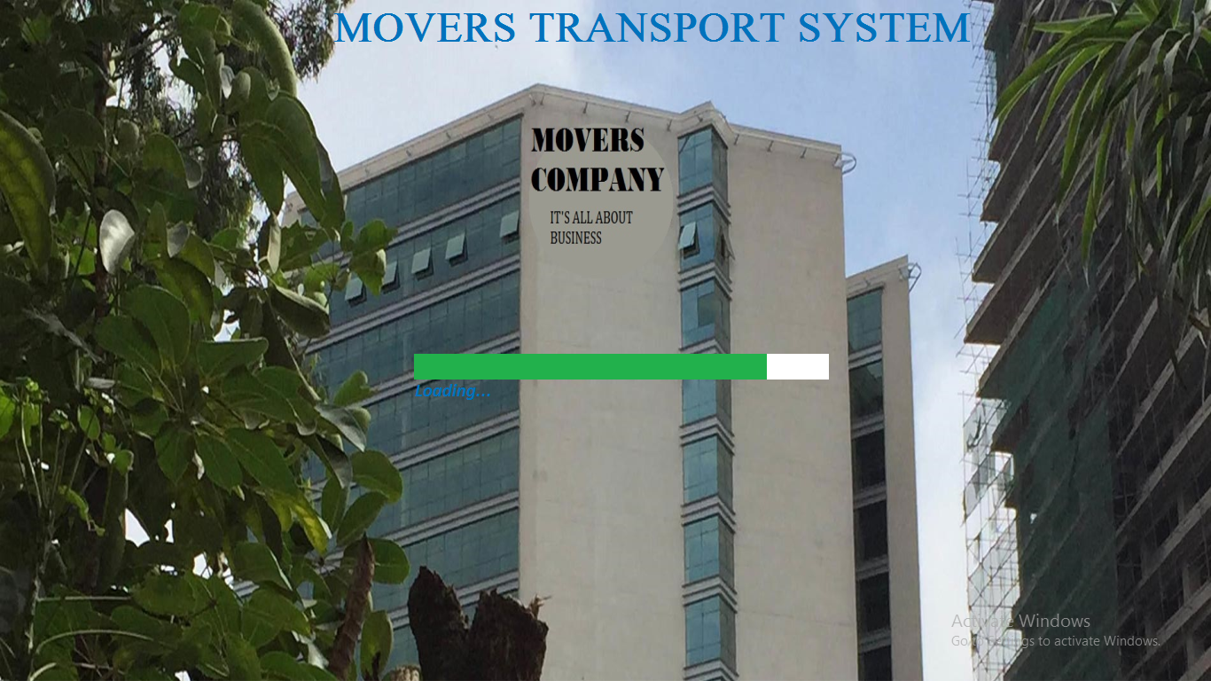

Then it will open the LOGIN on the login form, follow this procedure 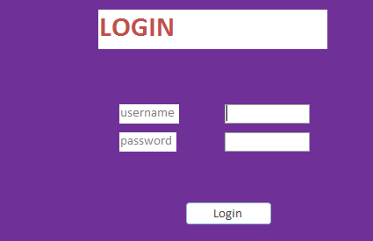

Click

Insert password

Insert name

It opens the main menu where the forms and reports are displayed

to the layout looks like this: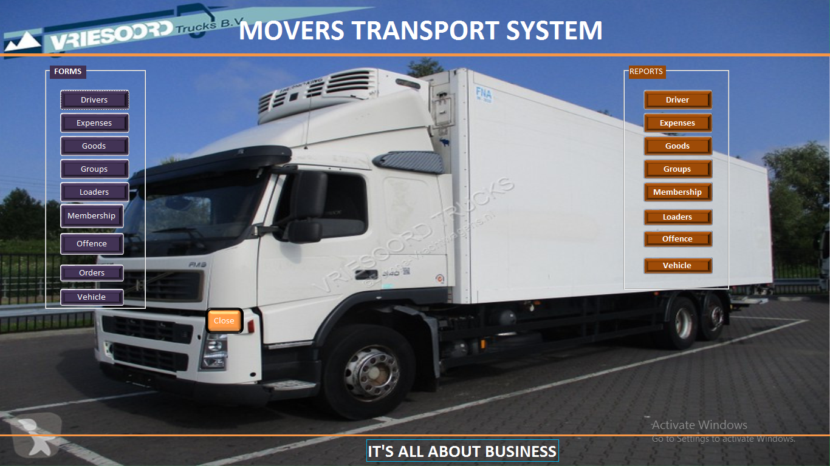

Forms

Reports

To open drivers report

To close the system

To open drivers form

***FORMS***

When you open a form it will display this, for example you open drives form, insert the drivers Id, drivers name, type of vehicle and then click SAVE

If you want to go to previous driver click PREVIOUS, if you want to close the form press CLOSE

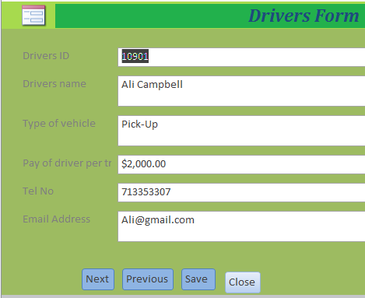

Delete

Click to go to next

Insert Drivers ID

To delete

To close

To save

Click to go to previous

***REPORT***

When you a report in the main menu for example drivers report this layout will appear.it will display drivers report 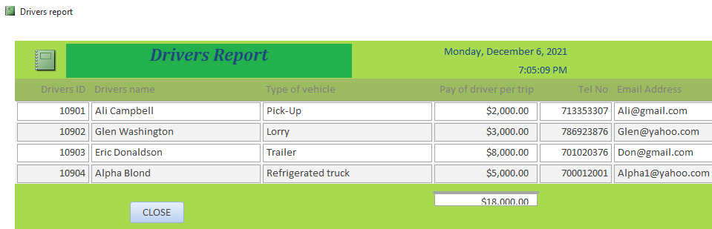

### Data manipulation

Driver payment query

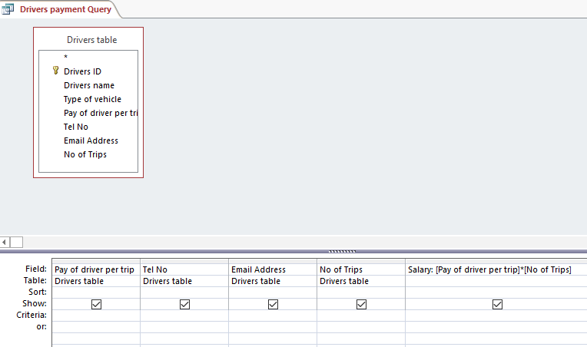

Total company expense query

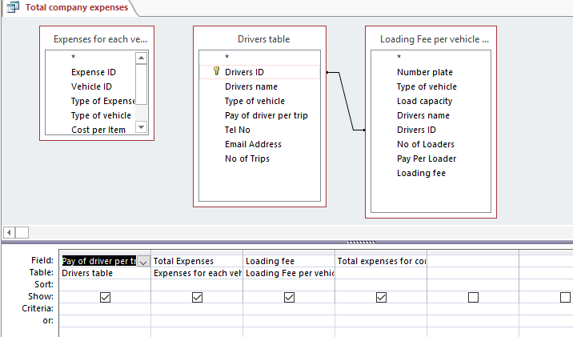

Tax payable

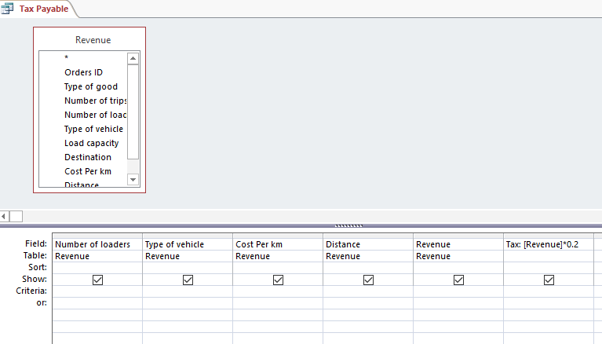

Revenue query

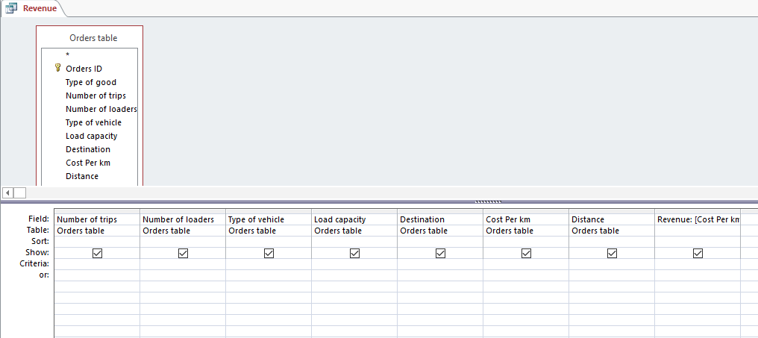

### User manual

#### INSTALLATION GUIDE REQUIREMENTS

This is guide meant to assist the user and technical staff in:

1. Installing the system
2. Loading and using the system

* Input
* Processing
* Output

1. Troubleshooting
2. Debugging

#### MINIMUM REQUIREMENTS:

HARDWARE REQUIREMENTS

* Processor: Pentium 4-1.2GHz
* Hard disk space: 20 GB
* Drive: CD-ROM or CD-RW
* Ram:2 GB
* Display: TFT 600 × 800 dpi LCD screen

SOFTWARE REQUIREMENTS

* Operating system : windows 13 and above
* Database Management System: Microsoft Access 2019 (Microsoft Office 2019 Office suit)
* Antivirus: Latest Version of Kaspersky (Optional)

#### HOW TO LOAD THE SYSTEM

* Run the system
* Double click on to MOVERS TRANSPORT SYSTEM

OR

* Right click on the icon to select open
* The system will open a SPLASH SCREEN which after a few seconds open LOGIN then the MAIN MENU.

The switchboard is displayed which allows the user to navigate the system. After updating system, click the CLOSE button to close the system

***How to load the system***

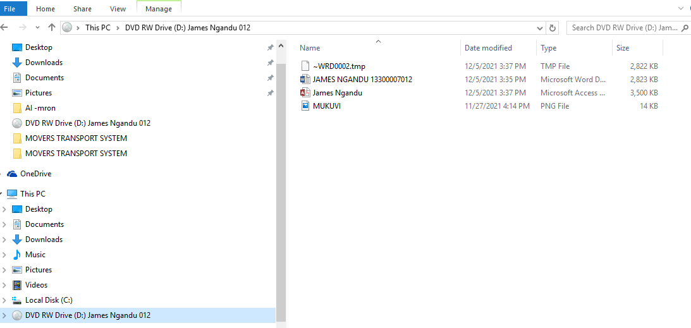

Double click the movers transport system

It will open the splash screen which opens the LOGIN



Enter 0000 as the password and username then click LOGIN

It opens the main menu where you open form and reports

For example open the drivers form

At the Drivers ID type the ID

At the drivers name type the name of the driver then the type of vehicle Telephone number and address.

#### **How to exit the system**

On the main switchboard, click on the close button and the database system will definitely close

CLOSE BUTTON

# MISCELLANEOUS

### Conclusion

The system is now able to perform this functions:

* Store all details containing members, drivers, loaders, vehicles, goods and also offences performed by the drivers, expenses incurred and also revenue.
* Display reports and forms about membership, drivers, loaders, vehicles, goods and also offences
* Perform calculations on the revenue and expenses through the query and display the profit.

### Recommendation for the system

I would like to recommend the following to complement the user of my system:

* *Use* **u.p.s** *to provide stable power.*
* *The system users should be trained on how the system runs.*
* *The system should be backed up using external storage media such as the hard disk.*
* *Parallel changeover*-to enable the users gain confidence on the system.

### Bibliography

Simplificare by P. Muasya and J. Kitonga, 2021.

S. Mburu, G. Chemwa, Longhorn secondary Computer Studies, 2018

### Appendices

Below shows a test data I used to enter details in the system:

***1. Expense table***

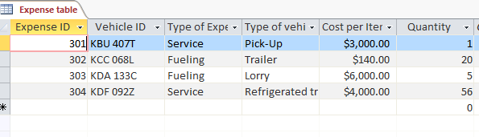

***2. Goods table***

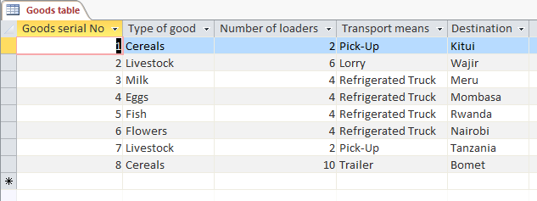

***3. Membership table***

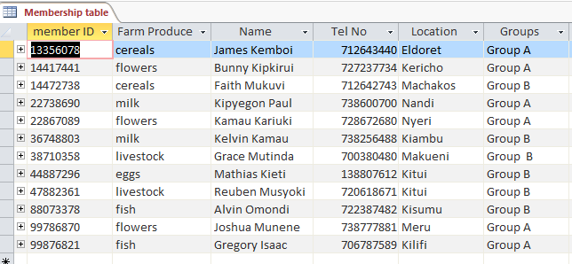

***4. Orders table***

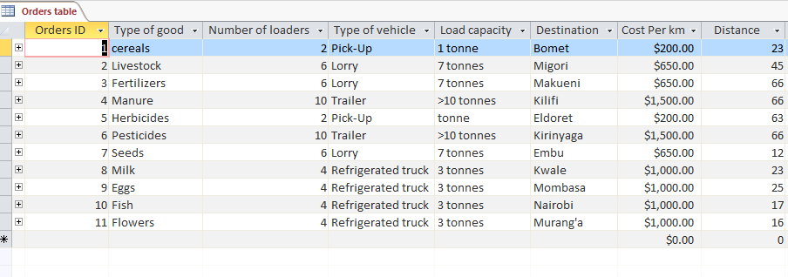

### Glossary

*System*- a set of organized components that interact in a given environment and within a specified boundary to achieve desired goals and objectives.

*Feasibility*- study carried by a system analyst to establish the costs and benefits of a system.

*Operational feasibility* – this establishes the extent to which the users are comfortable or happy with the proposed system.

*Schedule feasibility* – this establishes whether the development of the proposed system will be accompanied within the planned time.

*Technical feasibility* – establishes whether the technology available is sufficient or should be upgraded for the new system.

*Economic feasibility* – establishes whether developing the new system is cost-effective by analyzing costs and benefits of the proposed system

Data processing operation

Decision point based on true or false condition.

Any type of data stored in a stored in a system

Report of info displayed on the screen for user to read.

Database or structured storage of records or files.

Denotes manual input into a system.

Off-page connector.

Flow line that indicates logical flow.